  - News for HBPS department during COVID 19 era & afterwards

Since the start of the COVID 19 pandemic in Myanmar, the routine HBP surgeries, outpatient and inpatient care by our HBPS department, Yangon Specialty Hospital (YSH) became limited.
Despite of all obstacles and difficulties we faced, our HBP department still thrive forward to continue many academic activities such as active participation in virtual congress of APHPBA, Multidiscipl-inary team (MDT) meetings with international HBP surgeons via teleconferences.
8th Biennial Congress of the Asia -Pacific HPBA Virtual Congress, Bali held from 8th to 11th September 2021. Professor Tin Tin Mar participated as speakers in both 1st day & 3rd day of the congress in “Women in HBP Surgery”. On the 2nd day, Professor Sai Aung Nyunt Oo presented & discussed “Deceased Donor Liver Transplant Program “.
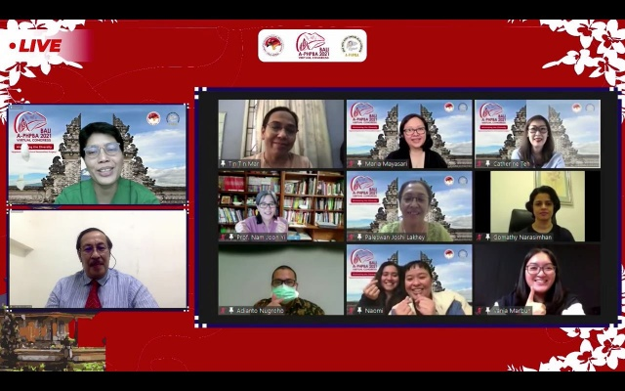
With the great help from faculties of International Hepato-Pancreato-Biliary Association (IHPBA), teleconference was held between Brisbane AHPBA, Pakistan and Myanmar Hepato-Pancreato-Biliary Surgeons since 2018. Every 2 months on the first week of the month and restarted again in 2022 May. Case based discusssion and each society live exchange the opinions for diagnosis dilemma and management issues. It is the pleasant occasion and great opportunities for younger surgeons to learn a lot.
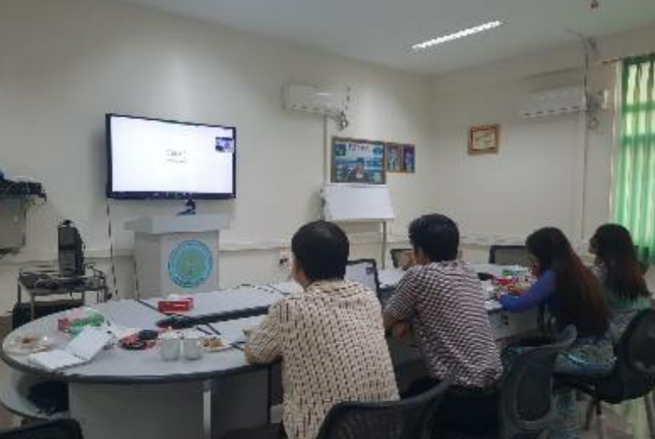
HBP session in APAN-53 (Asia Pacific Advanced Network) hosted by Seoul National University Bundang Hospital (SNUBH) March 7 to 11 2022, our HBP surgeons actively discussed with other experienced HBP surgeons from Kyushu University, Hokkaido University and Tokyo University and Kathmandu Hospital. This teleconference is also a great platform for productive exchange of ideas.
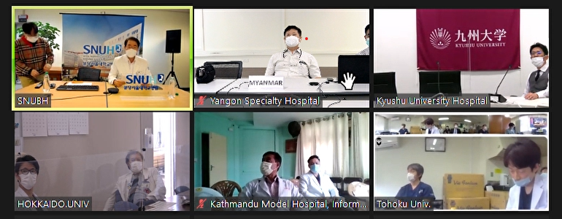

One registrar from HBPS department, Yangon Specialty Hospital finished the Observership program in 2022 under the guidance of Professor Susumu Eguchi from Nagasaki University Hospital, Japan. This program was provided by IHPBA and Japan society of Hepatobiliary and Pancreatic surgery (JSHBPS). She gained a variety of opportunities to learn not only liver transplantation but also hepatobiliary and pancreatic surgical procedures.

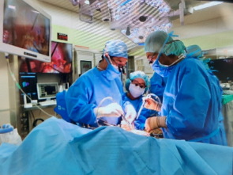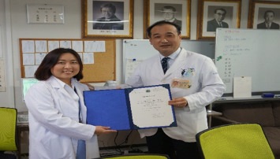

Our department organized the gathering between living donor liver transplant (LDLT) donors and recipients who underwent liver transplantation at YSH. Appreciation ceremony for LDLT donors held in 29th October 2022.

